**SCM: Student Christian Movement**

**Events at the Con**

**20 March (Thurs)**

***‘Harmony Day’* *Celebrating our International students:***

***Come along to the Courtyard (garden space at centre of the***

***building) to share something from your own culture:***

***some food, a joke, some news; a prayer, chant, song or all three!C:\Users\Bart\AppData\Local\Microsoft\Windows\Temporary Internet Files\Content.IE5\O3EBN0K1\MC900195590[1].wmf***

***In the Courtyard from 1.30pm***

**21 March (Fri) *St Patrick’s Delight: IHRH Concert 1.05pm***

Featuring: *Harp Tidings, The Conservatorium Tara Singers,*

*Two for Two, Bella Quattro,* Ian Henderson,

Kyla Matsurra-Miller, Amber Evans, Molly Collier-O’Boyle,

Mikaela Ward, Max Baillie, Juno Lin, Brienna Isokangas,

Caitie Matters, Zac Sakrewski, Jayce MacNeil, Bella Ambrose,

James Ball & friends.

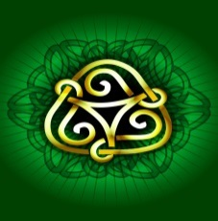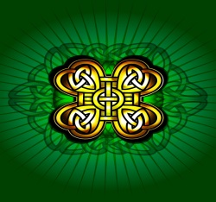

**9 April (Weds) *Pope Francis: getting real –* a discussion led by**

**Prof. Gerard Hall (ACU) with attendance of Griffith University**

**Chancellor Leneen Forde. 2.10pm**

**16 April (Weds) *Contemplative Dimensions of the Gospels* – an afternoon with Zen master Rev Dr Mervyn Lander. 2.10pm**

**21 May (Weds)**  ***Towards Marriage Equality* with Rev Chris Tyack**

**& Rev Ray Barraclough. 2.10pm**

**Fridays: 11 – 12noon** ***Together in Silence* (weekly Zen Group in Room 2.35)**